**Business Goal**

* To relatively create a map in faster way.
* Using model builder and geoprocessing to automate the whole Process of buffing, clipping, selecting and intersecting data to product the required map.

**Process Flow**

* Analyzing the business requirements
* Gathering the data
* Analysis of the data
* Cleaning and transforming the data- Attributes, colors, sections, symbology editing, etc.
* Enforcing the process flow by sectioning techniques and resources to needed for the project
* Start creating the models
* Validating the model
* Checking the output
* Creating the map

**Nested Model 1**

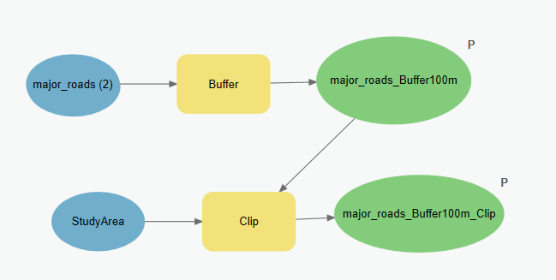

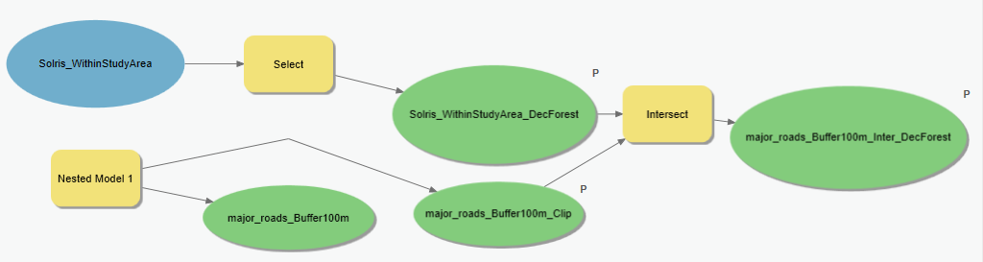**Nested Mode 2**

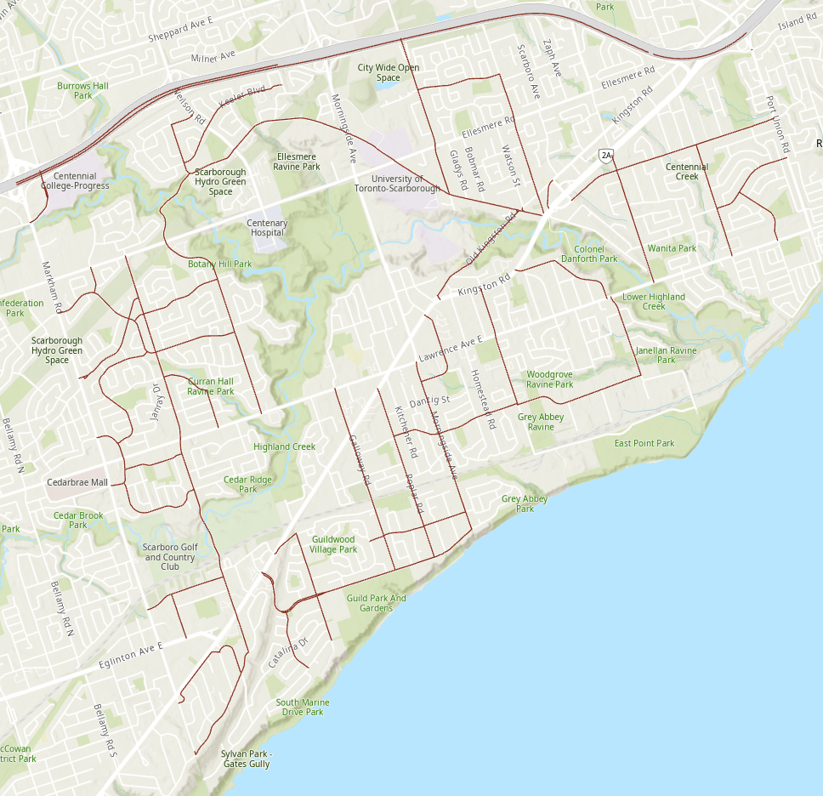**Major Roads Data**

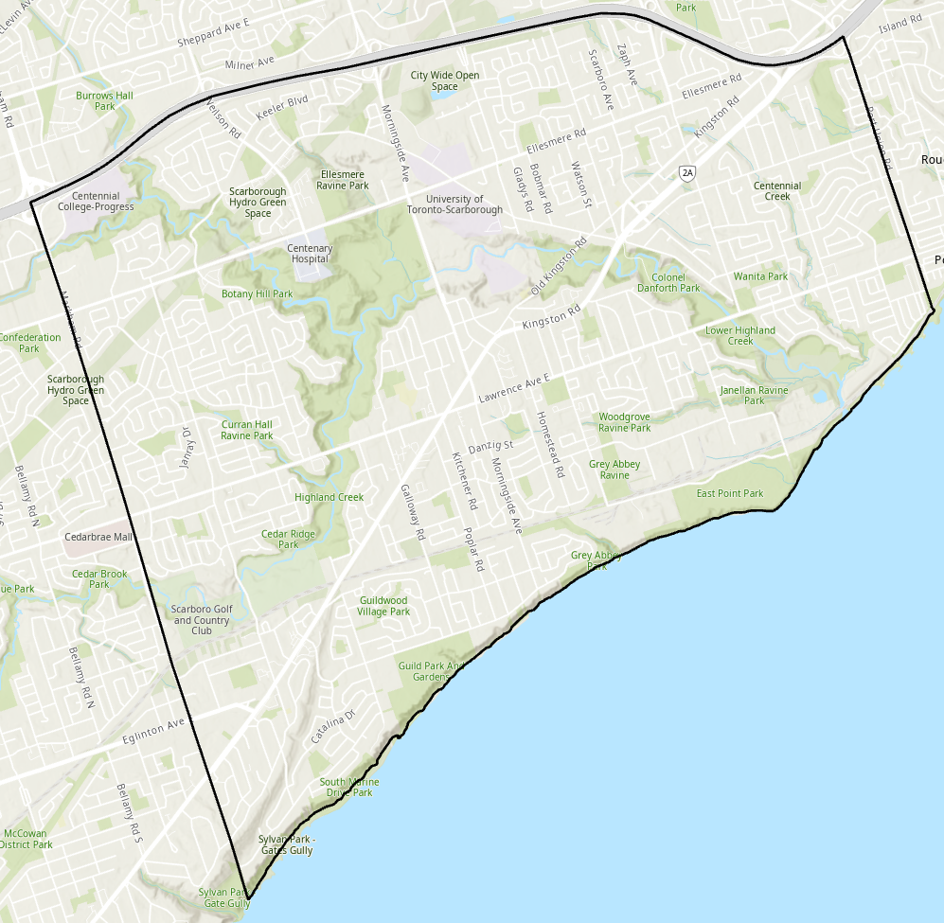**Study Area**

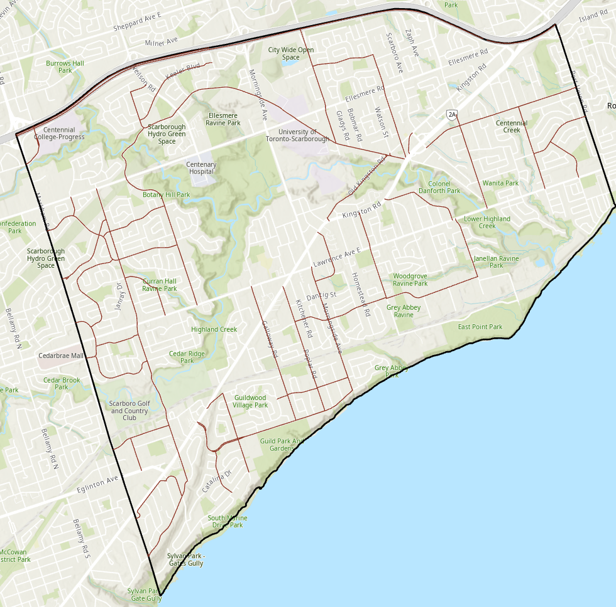**Study Area + Major Roads**

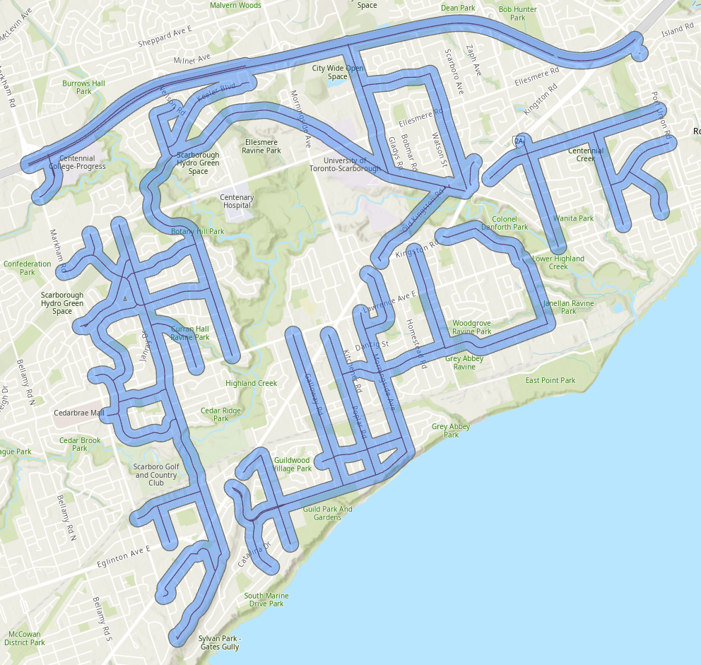 **Buffing the Major Roads @ 100meters**

**Major_Roads_Buffer100m_Clip**

* Clipping the buffed roads according the study area or target area.

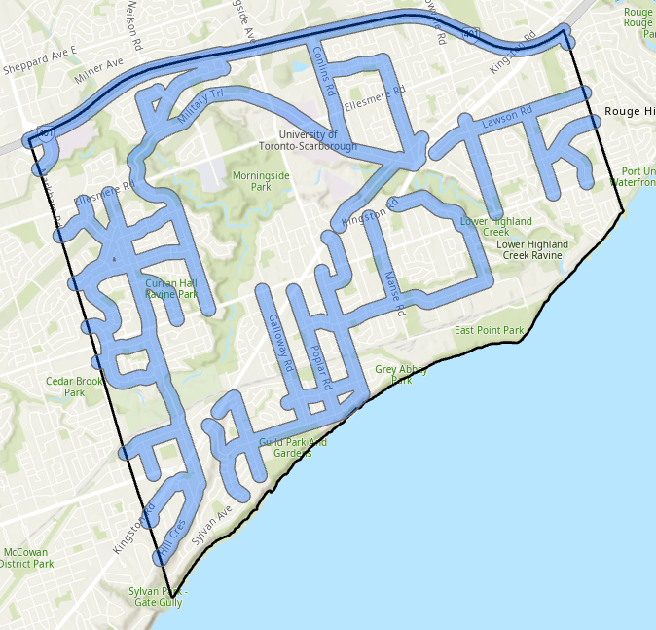

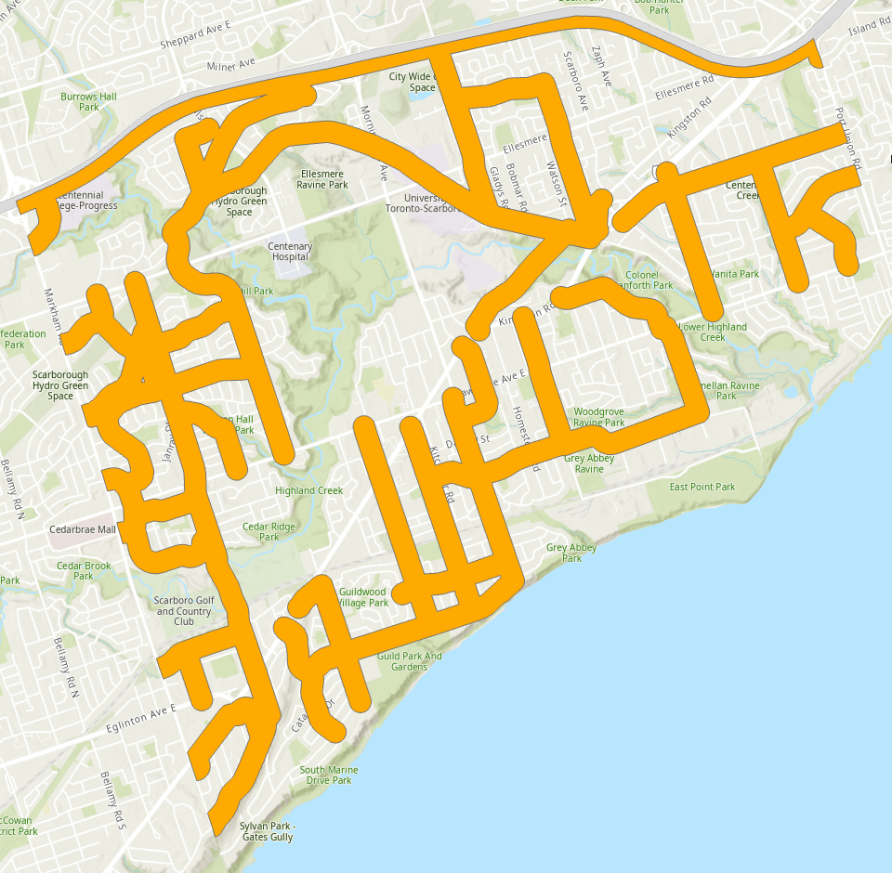**OUTPUT- Major_Roads_Buffer100m**

**BEFORE AND AFTER VISUALIZATION**

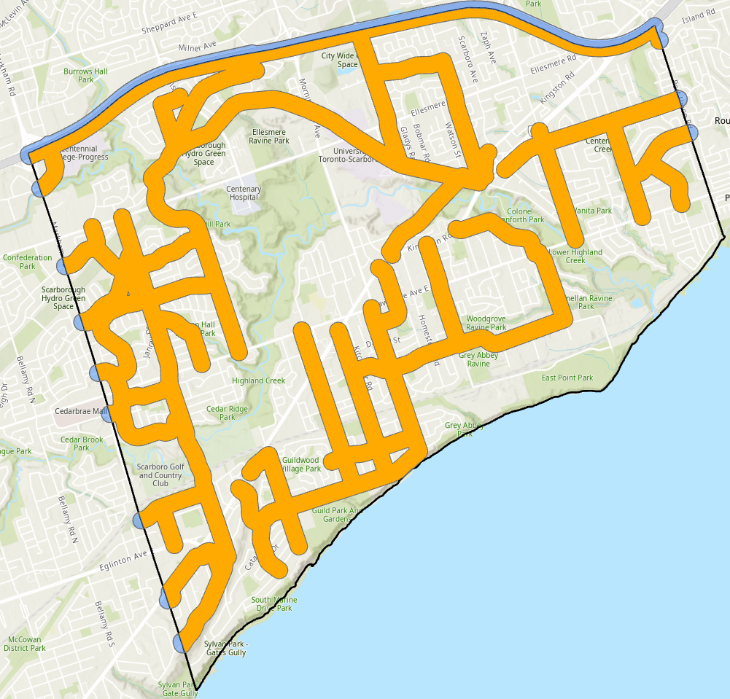Comparison of Buffed Road (Sky-blue) vs the Clipped Buffed Road (Orange)

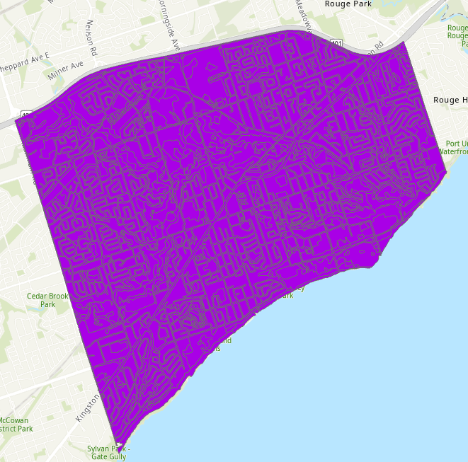**SOLRIS_WithinStudyArea**

**SELECTION PROCESS**

* 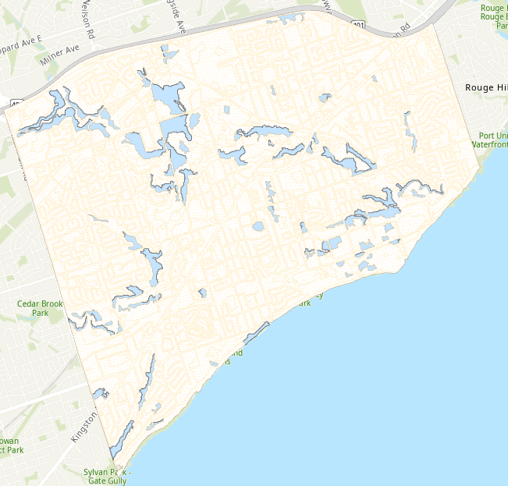Deciduous Forest in Solris Study Area

**INTERSECTION PROCESS**

* 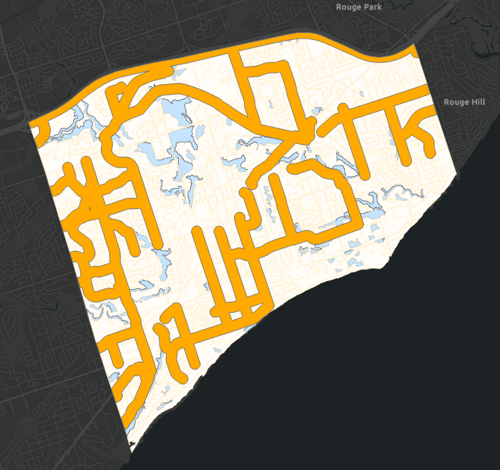Intersecting the clipped major roads (Buffed @ 100m) and Solris_withinStudyArea_DecForest

Output

* You may be wondering how did this happen. The data that you are seeing right now visually were actually the 100m buff roads. Under it where the deciduous forests data.

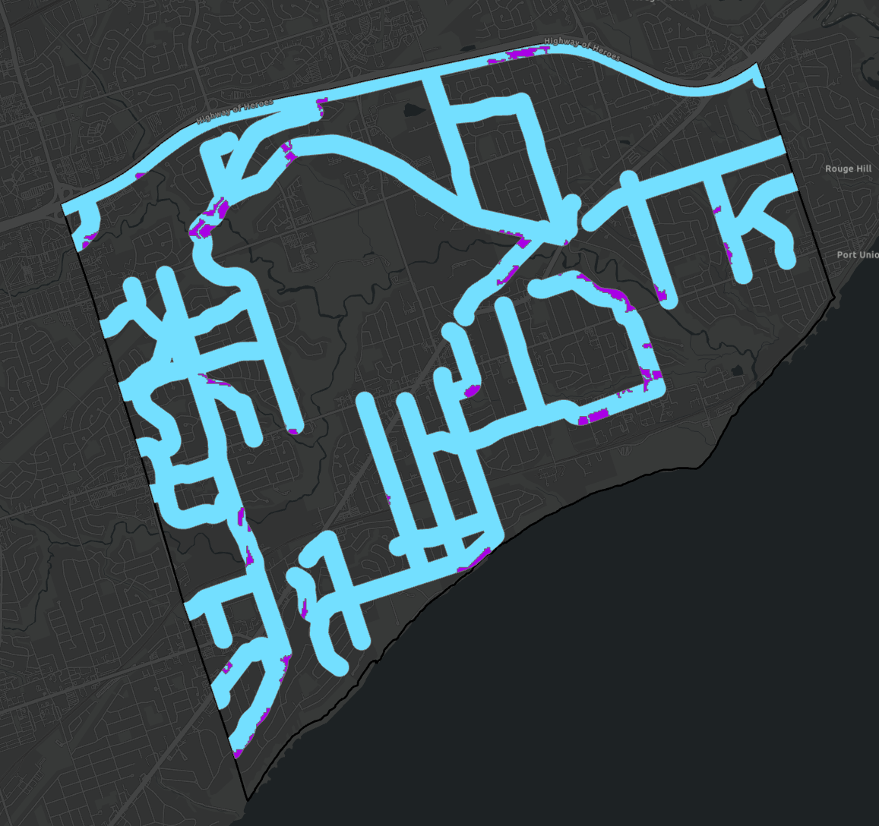

Output

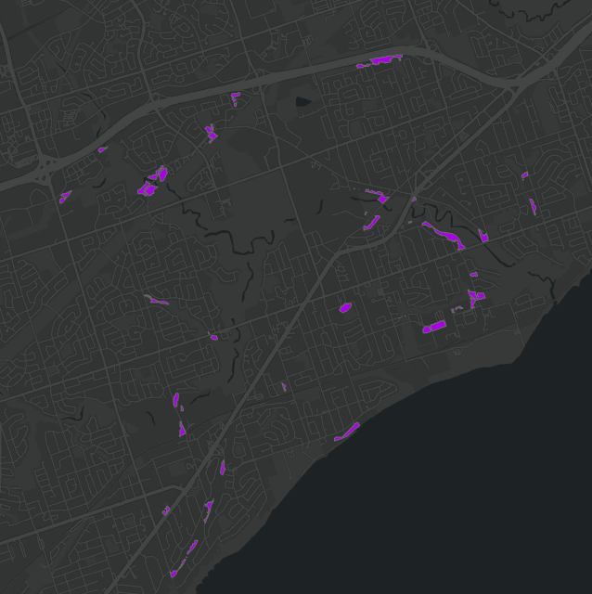

**One Hot Spot Analysis**

Study Area Vs Deciduous Forest @ 100m major roads

1. 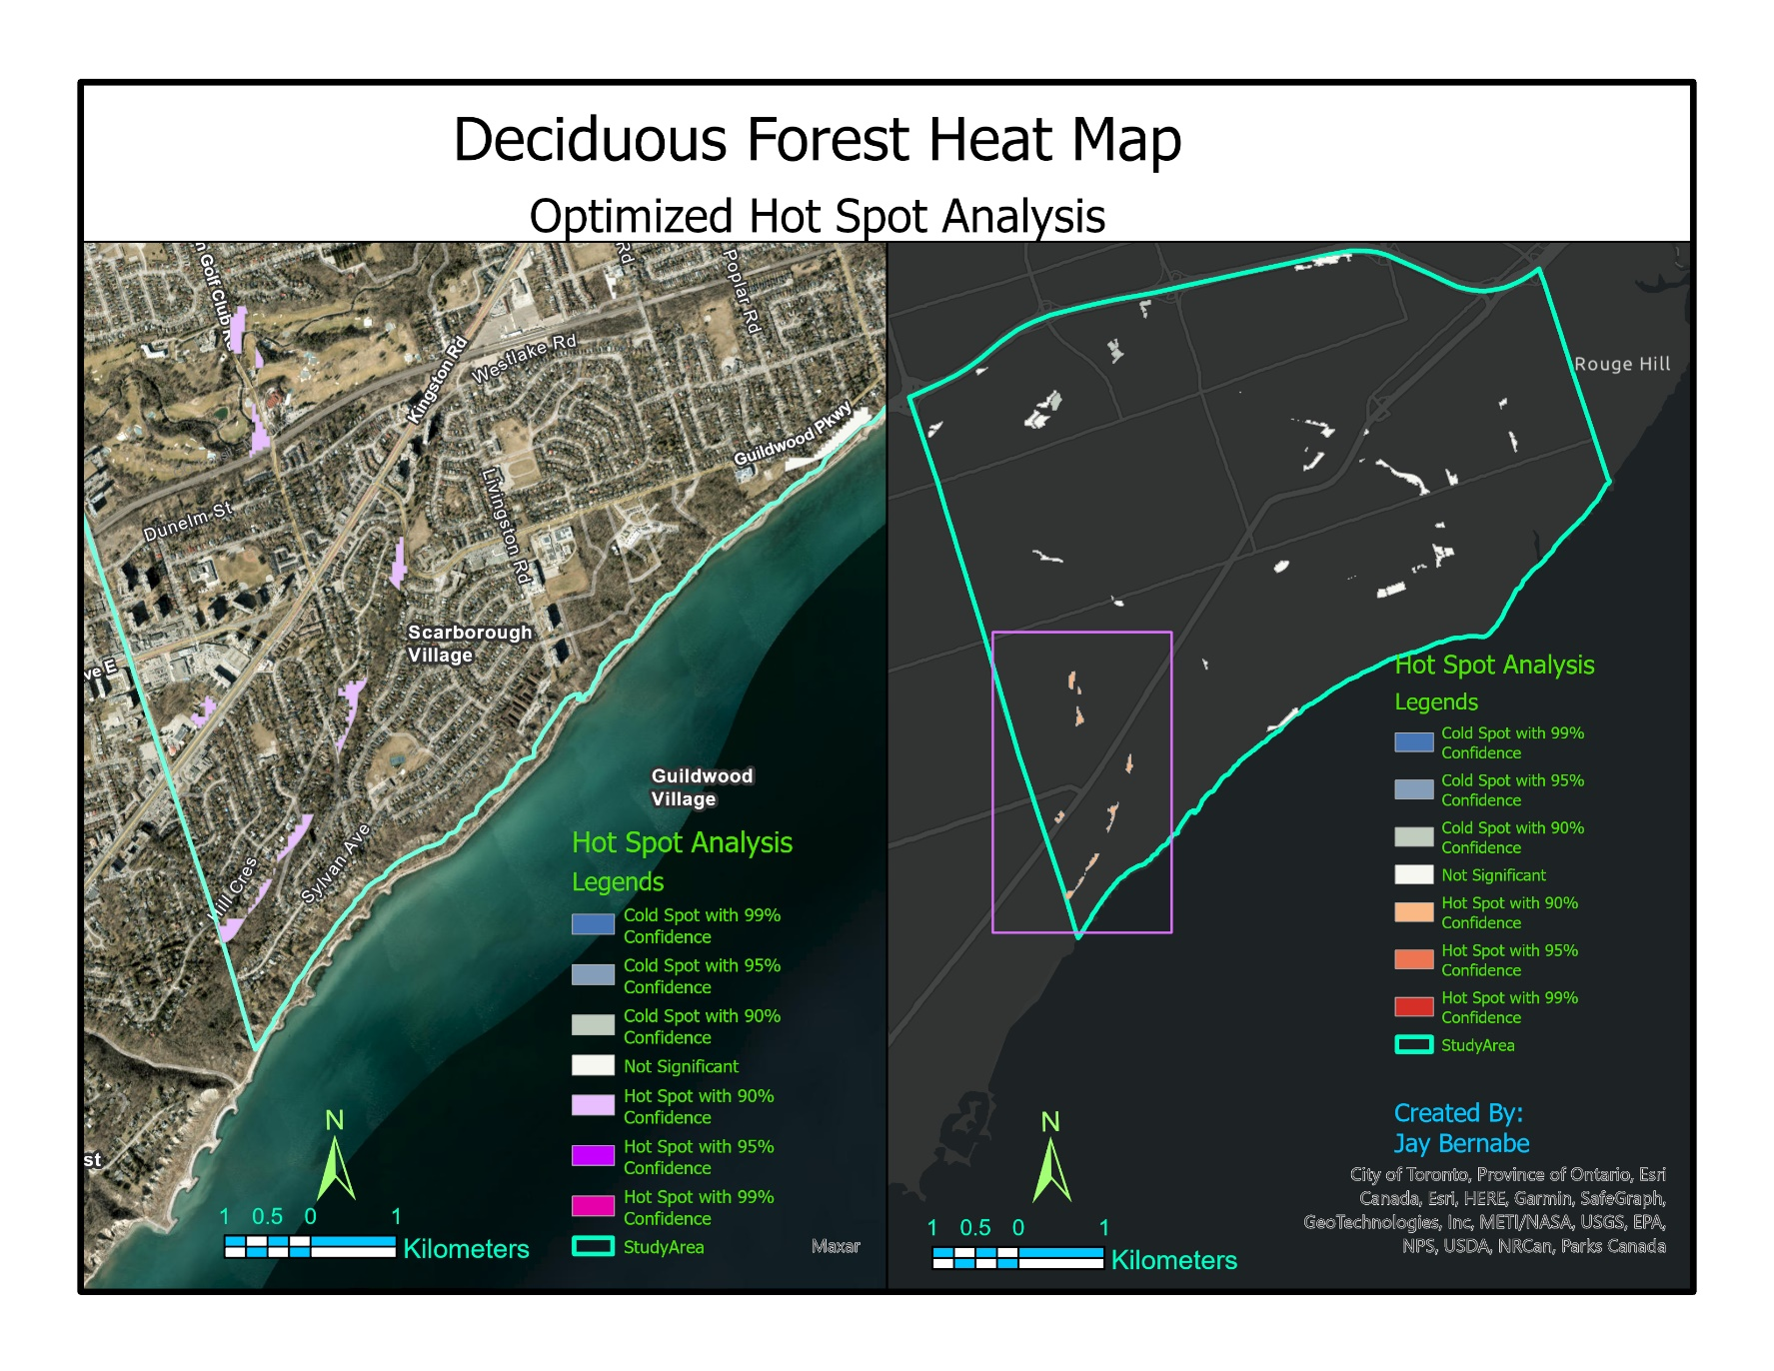One Hot Spot Analysis – Deciduous Forest @100m major roads

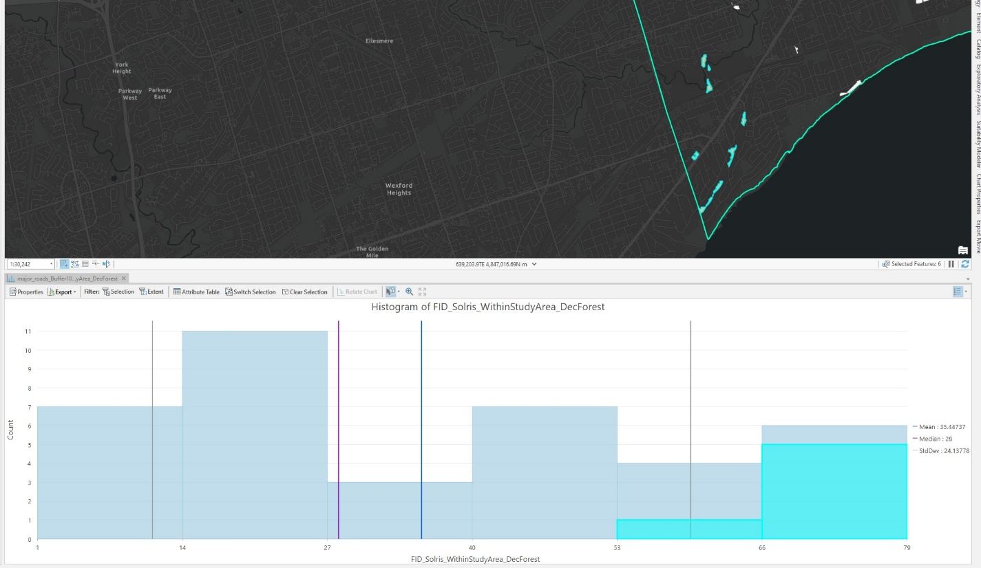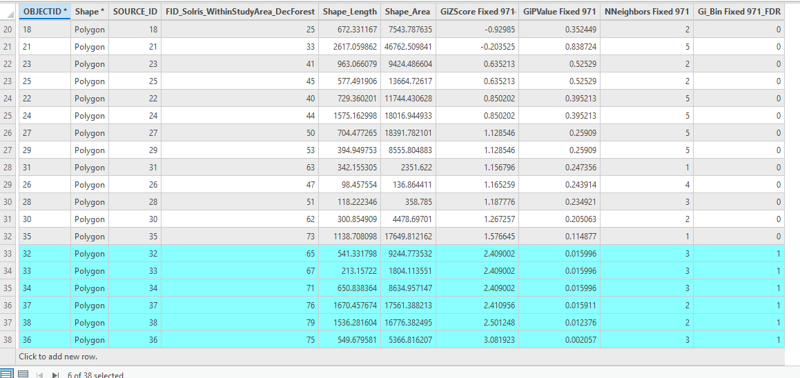

1. One Hot Spot Analysis- Study Area

